Project: Amazing Farm to Fork
Difficulty: Level 1

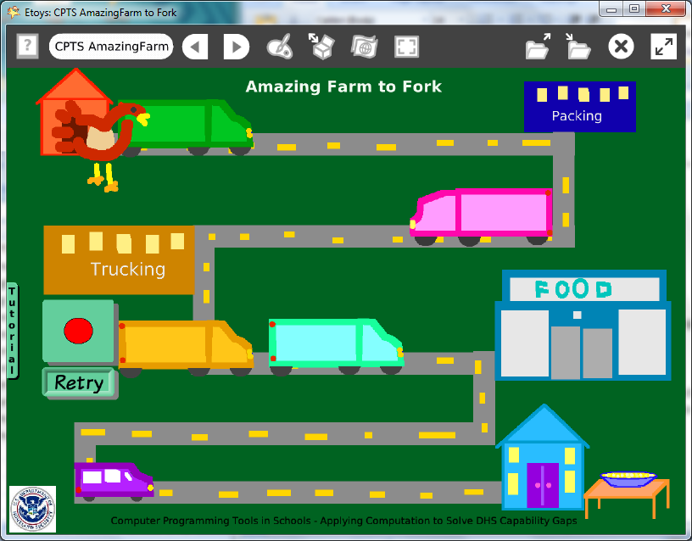

Time: Five 45 minute labs

Challenge:
Design a game that is a maze of showing locations and transportation in the food distribution network for a farm produced food.

Programming:
Basic script tiles, conditional statements, variables, constructed tiles, random number tiles, scripts that are ticking, paused, and normal, scripting tiles that start and stop other scripts.

This project is not difficult programming but requires careful planning and thought for each script. The sketches take time but the time thinking about all these objects deepens the understanding in the complexity of food distribution. Thinking about how to show all the stages that a product travels through and the modes of transportation and imagining how many of each is involved in real world food distribution.

There are useful commands in the Halo’s white menu to keep objects in the correct layers: bring to front, send to back, resist being deleted, resist being picked up, and be locked.

This project makes use of the Scripting Category of tiles to start, pause, and stop scripts based on events while the project is running. There are no Quick Guides for scripting tiles. There are Help balloons that are useful.

Things you’ll need to know:
Quick Guides
- Paint Tools/ All
- Halo Handles/All
- Supplies: Joystick
- Script Tiles: Tests Category, Overlaps Dot, X and Y Tiles, Hide and Show
- Menus: Button to Fire a Script

Things to think about:
- How can one object control the motion of another object? Which script should be in control?
- Could there be a world timer that is used to start and stop scripts? Would it be more efficient?

Extensions:
- Research the food distribution network to see how many facilities are involved in the distribution of a common food such as French fries, milk, or a cola drink.

NETS for Students:
http://www.iste.org/standards/nets-for-students/nets-student-standards-2007.aspx
1. Creativity and Innovation: a, b, c
2. Communication and Collaboration: b
3. Research and Information Fluency: a, b, c
4. Critical Thinking, Problem Solving, and Decision Making: a, b, c
5. Digital Citizenship: a, b
6. Technology Operations and Concepts: a, b, c, d

CSTA:
CSTA Level II: Objectives and Outline
http://csta.acm.org/Curriculum/sub/CurrFiles/L2-Objectives-and-Outlines.pdf
Level II objectives for middle school students are furthered through studying a programming language well enough that the student is proficient with it. Whether the language is Etoys, StarLogo TNG, or Scratch, it is the ability to use the language to express ideas that is valuable. A student skillful enough to use any programming language to express ideas, solve problems, model behaviors, simulate data, or to educate or entertain is an entitled person in today’s society. Topics of particular note are:
Topic 2: Problem Solving
Topic 6: Connections between Mathematics and Computer Science
Topic 11: Programming Languages
Topic 13: Multimedia

Common Core Standards Mathematics:
http://www.corestandards.org/the-standards/mathematics
6. EE.26.EE.5
7. EE.3
8. F.1, 8.F.4

Teacher Notes:
Materials: This information is also in the tutorial flap for this project. Students should include relevant information about the food they research and use it to inform the people who play their maze.

Think about it:
An egg weighs 2 ounces.
4.862 million short tons of eggs are produced in the US every year.
Each person in the US consumes 32.4 pounds of eggs per year.

A carton has 12 eggs.
There are 20 cartons in a box.
There are 4 boxes in a crate.

Semi-trucks are packed with crates stacked 5 crates wide, 6 crates deep and 5 crates high.
How many eggs are in a truckload?

Check today's price for a gallon of diesel fuel and estimate how much it costs to move all the eggs an average of 30 miles from farms to homes.

What would be the advantages and disadvantages of raising chickens in back yards? www.greenchickencoop.com www.chickencoopsource.com

Comments: Objects - Scripts – Decisions
This project has many objects and each was sketched and named. The list includes: chicken, egg, four trucks a car, a house, table bowl, fork, five buildings and the maze.
The egg has several scripts: one connects its motion to that of the joystick. The others include a test that makes the truck or car move if the egg is over it.

It takes time to draw this many objects but thinking about these objects increases knowledge about the complexity of food distribution systems. The projects can show a product distribution points and modes of transportation and imagine how many of each is involved in real world food distribution networks.

Asking students to imagine the number of jobs that depend directly, or indirectly, on providing food to 311,800,000 people in the United States can be the source of research questions and class discussions.

Example Scripts:
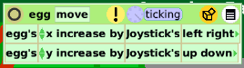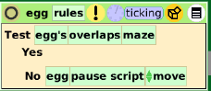

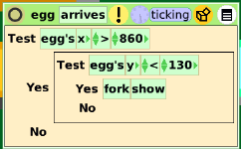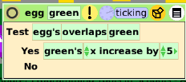

Student Notes:
Think about it:
An egg weighs 2 ounces.
4.862 million short tons of eggs are produced in the US every year.
Each person in the US consumes 32.4 pounds of eggs per year.

A carton has 12 eggs.
There are 20 cartons in a box.
There are 4 boxes in a crate.

Semi-trucks are packed with crates stacked 5 crates wide, 6 crates deep and 5 crates high.
How many eggs are in a truckload?

Check today's price for a gallon of diesel fuel and estimate how much it costs to move all the eggs an average of 30 miles from farms to homes.

What would be the advantages and disadvantages of raising chickens in back yards?
www.greenchickencoop.com
www.chickencoopsource.com

